Sport Premium Report
From September 2013, all schools have been provided with funding to support the Olympic legacy and to enable the delivery of effective sports provision. Within the Diocese of Salisbury Academy Trust we aim to provide high quality sport. At St. Peter’s CE Primary Academy, during only our first year of opening, we have provided the following:
- High Quality Sport’s Coaching through in-house CPD and hiring of specialist sports coach.
- Investment in sports equipment and facilities; this is especially important as a brand-new school.
- A school-wide passion for well-being through sport and fitness, including weekly PE sessions and yoga.
- Involvement in competitive sports such as the Salisbury School’s Mini-marathon.
- Extra-curricular sports provision, including multi-sports and running club.
Impact Report for Last Year
Our Sport Premium Funding for the last academic year was: £20,000. This money was used as follows and impacted as detailed below.
Activity | Budget | Impact Assessment
Continue to positively promote environmentally friendly and healthy travel choices.  Become a healthy travel hub for the wider community by lending out bikes to families who do not have access to healthy ways of travel. | £4,000 (for new bikes at various sizes)  £600 (training of staff and Y6 pupils to manage minor repairs of bikes loaned out, equipment to repair minor repairs to bikes) | St Peter’s purchased some more bike sheds this academic year in line with the expansion of the school. All bike sheds were consistently full throughout the year, showing families are choosing a more active route to school. There are significantly less cars around the premises at pick up/drop off times.  Other schools were contacted about how they run their bike schemes and bikes are going to be purchased this academic year when full research about safety of the site has been evaluated.  St Peter’s has introduced a walking bus throughout the estate, which operates multiple mornings a week. We hope to roll this out to every day in order to allow children to get to school on a bike, scooter or walking even if their parents cannot take them.
CPD for staff through team teaching with specialist coaches (Coach 23).  Teachers to be confident in teaching PE and lead some sessions | £6,500 | 100% of teachers were able to spend time looking through PE lesson planning and all taught at least one PE lesson per term.  100% of HLTA’s were involved with leading PE sessions with multiple year groups. It was reported that they ‘could appreciate the progression of skills in students’ and that they ‘enjoyed seeing all pupils enjoy taking part in exercise’. All HLTA’s were observed delivering PE by SLT and reflected on their own practice after wards.  100% of newly qualified teachers and their TA’s reported feeling ‘confident to teach PE across multiple sports’.
Raise the profile of PE and sport across school.  Continue to offer a wide range of clubs and sessions within school which promote healthy living.  These to include after-school clubs, dedicated lessons to mental health and physical health and set time within PE sessions to discuss the body in relation to their physical activity. | £1,500 | The PE profile was improved drastically last academic year. St Peter’s hosted many sports related days such as ‘wellbeing day’, ‘santa dash’ and the ‘colour run’ which all involved the children running a route through the estate adjacent to the school. Parents and carers came to watch and was seen to be a key moment in strengthening the community around PE.  More sports clubs were added into the after-school club list this year including tennis, yoga club and running club. These clubs were oversubscribed and had a waiting list to take part. Attendance at these clubs were high at over 90%.  The importance of physical and mental health was discussed during the school-wide off-curriculum ‘wellbeing day’, as well as during Klassenkage time weekly. Students reported ‘looking forward to sharing my worries and advice to my friends during Klassenkage’ and that they ‘felt safe to talk about my mental health within school’.
Year 5 and 6 catch-up swimming programme that boosts the lessons in Year 3 and Year 4. (This may take the form of an intensive day/week course)  Increase the total number of Year 6 leavers able to swim 25m. | £1,100 | 90% of Year 6 children left St Peter’s being able to swim 25m.  All children in Years 6 and 3 were able to receive a terms’ of swimming lessons.
Continue to increase participation in competitive sport with inter-school sports competition to include opportunities for children in lower Key Stage 2 and Key Stage 1.  Focus more on KS1 involvement – hold a competitive sports day for Salisbury schools (KS1).  St. Peter’s to engage with the local sports partnership and tap into local events as well as arranging their own. | £1,100  To include:  (Bibs - £30  Existing equipment repair - £50  Football kit - £100  Membership of local sports partnership £100 | Across years 4, 5 and 6, St Peter’s participated in more inter-school competitions than we have ever done in previous years. In most cases, we made it to the county finals. The children looked forward to these and they boosted morale around PE massively. Teachers reported a ‘buzz around PE and the importance of taking part in a team’. Other students enjoyed ‘celebrating with my friends when they got through to county finals’.  We did not hold a KS1 sports competition due to the Salisbury Sports calendar being full, but plan to get more KS1 children involved in sporting activities outside of PE lessons.
Improve enjoyment of recreation time by encouraging active play during break times and lunchtimes.  TV’s on KS2 end of school building displaying dance/workout videos at lunchtimes. Adults to monitor this outside. Encourage children from ALL year groups to engage to promote active activities during break.  Climbing frame – ‘Scramble net log climber’ (Sovereign play)  Fitness trail playground activity trail  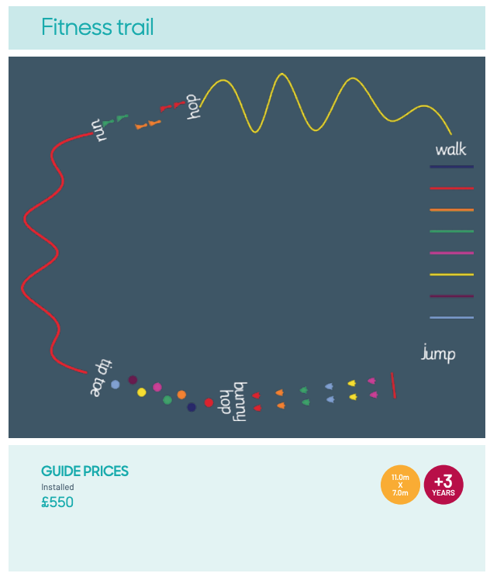  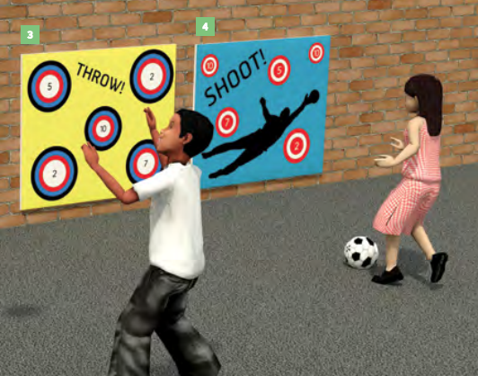  Ball targets (on wall)  Playground active packs | £200 x 2 (TV)  £50 x 2 (TV weatherproof outdoor case)  £2550  £550  £1400  £200 | We enquired about a Trimble trail to be installed in the school grounds but this proved to be much more than anticipated as the ground needed much preparation and materials to make it safe. Our field required work due to the ground conditions and so this is where the funds went for this aspect of the budget. The field is now much more equipped to host sporting activities and is safer for the children to be active on.  Many different playground activities have been purchased this year including construction materials, small world materials, safe equipment storage, outdoor classroom resources.  TV’s will be purchased the next academic year due to there now being electric sockets outside. Playground markings/target panels are still to be purchased the next academic year once the outdoor work for the extension is complete.
Total Budget | £20,000

Year 6 Swimming
Descriptor | Children achieving target (%)
Swim competently, confidently and proficiently over a distance of at least 25 metres | 90%
Use a range of strokes effectively, for example, front crawl, backstroke and breaststroke | 90%
Perform safe self-rescue in different water-based situations | 100
Has St. Peter’s used sports premium funding to provide ‘top-up’ lessons for pupils in Year 5 and 6 | Yes

Continued overleaf

Action Plan for Current Year
Our Sport Premium Funding for the current academic year is: £19,100. The following plan details how we plan to use the money to maintain and improve provision.
Activity | Budget | Anticipated Impact
Sports coaching and mentoring  Staff CPD is in place for all class teachers throughout the year, including New Sports Leader undertaking leadership specific PE training and team teaching across the school with existing teachers and TAs  High quality PE lessons are taught and incorporate team teaching and 1:1 coaching for staff.  Subscription to Get Set for PE to support staff CPD and to ensure a clear progression of knowledge and skills. | £895 (Level 5 Certificate in Primary Physical Education Certificate)  £9,045 (Specialist PE teacher)  £585 for Get Set subscription  Total cost £10,525 | Staff feel confident to deliver high quality PE lessons, using the national curriculum and our PE vehicle Get Set for PE as support.  As a result of coaching and team teaching, the quality of PE lessons is 100% good or better.  Children have a good understanding of the progression of knowledge and skills needed to access the PE curriculum and demonstrate these well. This is measured through pupil voice and ongoing formative assessment by their teacher.
To raise the profile of our school teams at a variety of sporting events.  To lessen the gap between disadvantaged and their peers in regard to access to kit. | 30 x windbreaker jackets roughly £750  Range of football boots x 10= £250  Another full set of purple football kit x 12= £300  Shin pads x10= £75  Range of goggles x 10= £50  Feather flag= £120  Total cost: £1,545 | 100% of teachers to have had training on how to deliver an effective PE session by specialist coaches. Specialist training for teachers in order to increase confidence, knowledge and skills.  100% of teachers to deliver at least one session of PE to their class every half term.  Teachers to be confident in planning, preparing and adapting sessions for their class.
Year 6 catch-up swimming programme that boosts the lessons in Year 3.  Increase the total number of Year 6 leavers able to swim 25m.  Increase the amount of children who feel safe in the water and enjoy spending time in the water. | (including transport/coaches/pool hire)  £2,000 | 95% of pupils are able to swim 25m by the end of Year 6.  100% of pupils in KS2 to have been in the water and received coaching from a swimming teacher upon completion of the terms’ swimming.  100% of pupils know how to be safe in the water and how to behave around bodies of water in public.
Continue to increase participation in competitive sport with inter-school sports competition- transport  St Peter’s to hold more active clubs and sports events for KS1.  Resource playground activities and PE lessons | Transport to and from competitions= £2,000  To include:  Sports equipment - £1000  Membership of local sports partnership £100  PE platform= £500  Total cost: £3500 | Increased participation in sports clubs.  Increased participation in the mini-marathon.  Students to feel active and engaged in school – teachers to be using active breaks within their school day (dance breaks, 2 minute runs to break up the sessions, mindfulness candle to allow children to regulate after activity).  100% of KS1 classes ton have engaged in a inter-school sports competition aside from sports day.
To give the children access to a broader range of sporting pursuits such as climbing walls, archery etc. Provided experiences by external agencies | £1500 | Children have a greater understanding of the wide array of other ways to keep fit and stay healthy.
Total Budget | £19,100

Monitoring and Evaluation:
- This report will be updated at the end of the academic year to identify the success of the above initiatives and the impact that they have had.
- Delivery will be monitored by the PE and Sports Leader in the first instance. This will be overseen and managed at senior level by the Senior Teacher.
- We will monitor the take-up of activities, including by children entitled to Pupil Premium funding.
- Monitoring will include observations of teaching, drop-ins to clubs run by school staff, volunteers and outside agencies to ensure that provision is of high quality. We will review progress against this plan and to identify next steps, on a termly basis.

